**TECHNICAL REPORT ON PROJECT 5.**

**BY**

**ADEGOKE BLESSING TUNMISE**

**VEPH/20B/DA189**

**Task 18B**

OUTLINE

1.     Introduction

2.     Story of Data

3.     Data Splitting

4.     Pre-Analysis

5.     In-Analysis and Insights

6.     Data Visualization

7.     Recommendations and Observations

8.     Conclusion

### ****1. Introduction****

This report presents a business analysis of sales and profit for Jerry Zion sales trends across customer segments, regional distributions, delivery performance, and sales channels. The goal is to understand customer behaviors, regional profitability, and factors impacting overall business performance, thereby supporting strategic decisions in operations and marketing.

**2. Story of the data**

The dataset comprises transactional and operational records of a retail business, covering several years and containing sales, profit, shipping, and delivery metrics across customers, sub-categories, regions, and time periods.

**Data Structure:**

* **Sales and profit** across customers, regions, and time.
* **Quantities sold** by customers.
* **Delivery performance** by number of delivery days.
* **Profit analysis** by shipping mode and sub-categories.

**3. Data Splitting**

**Independent Variables:**

* Customer Name
* Region
* Order Date
* Ship Mode
* Sub-Category
* Delivery Days

**Dependent Variables:**

* Sales
* Profit
* Quantity

**4. Pre-Analysis and Intended Insights**

The analysis focuses on the following questions:

* Who are the top-performing customers by sales and quantity?
* What are the trends in sales and profit across different years and quarters?
* Which regions and sub-categories are most profitable?
* How does delivery speed affect business operations?
* What shipping modes yield higher profitability?

**5. In-Analysis and Insights**

* **Top Customers:** Sean Miller, Tamara Chand, and Raymond Buch lead in total sales, with figures exceeding $15,000 each.
* **Sales Trend:** The year 2011 recorded the highest profit, with Q4 being the most profitable quarter.
* **Regional Performance:** The West region contributes the highest profit, followed by the East and South.
* **Shipping Mode:** 'Second Class' and 'First Class' ship modes yielded relatively higher profits.
* **Sub-Category Performance:** Categories like Phones, Chairs, and Binders emerged as high-profit areas.
* **Delivery Trends:** Most deliveries were made within 2–4 days, indicating a strong logistics setup.

**6. Data Visualization**

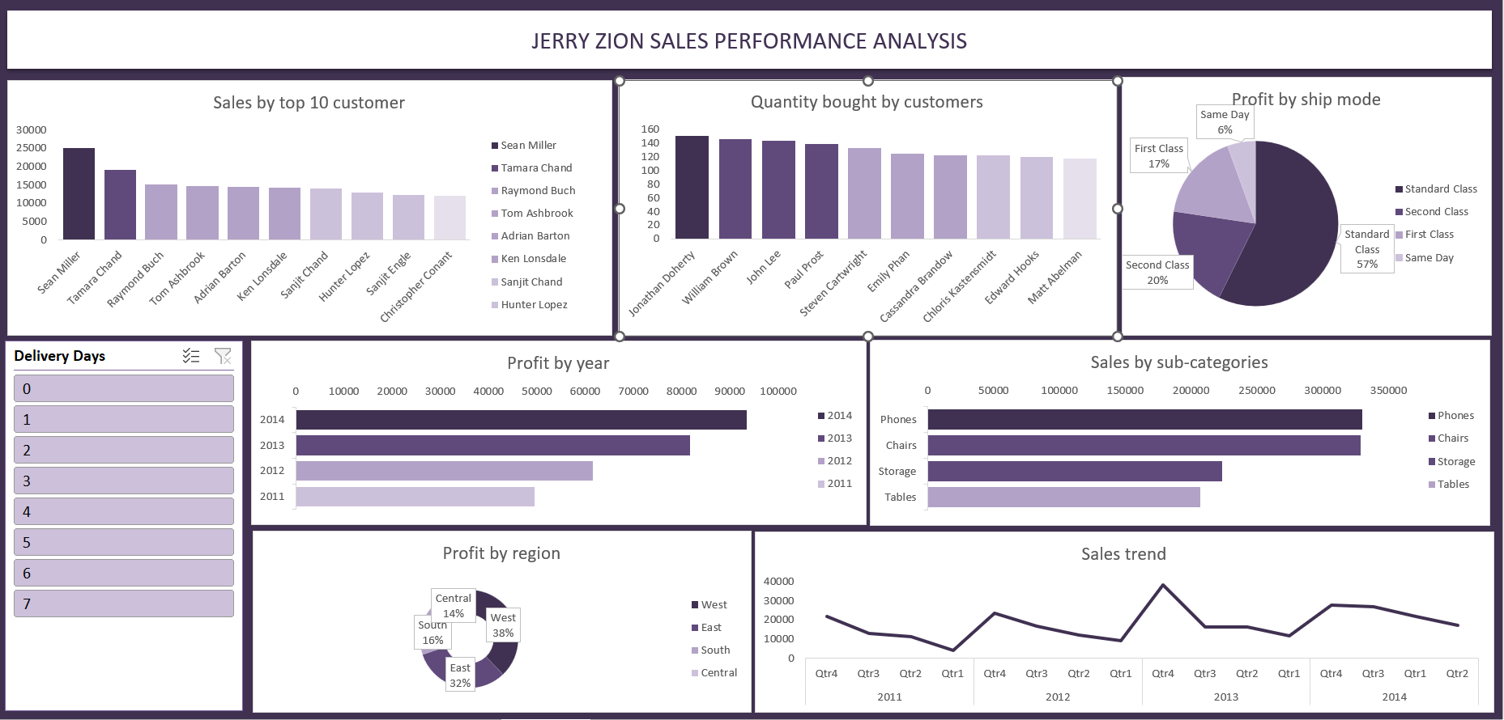

**7. Recommendations**

• **Customer Engagement:** Focus on retaining high-value customers through loyalty programs and personalized offers.

• **Regional Strategy:** Invest more resources in the West and East regions, and explore opportunities to boost profits in the South.

• **Inventory Focus:** Prioritize stock availability for high-performing sub-categories such as Phones and Chairs.

• **Logistics Optimization:** Maintain or reduce delivery times to sustain customer satisfaction.

• **Shipping Efficiency:** Evaluate the cost-profit balance of shipping modes to optimize margins.

**8. Conclusion**

The analysis reveals key contributors to the business’s profitability, both in terms of customers and operational factors. Understanding these patterns enables data-driven decisions in customer management, supply chain optimization, and regional investment, laying a foundation for strategic growth.